Part A
Name:- Parva Gaglani
Roll No:- C172
Subject:- Data Structures and Algorithms
Program: B Tech-CE 2nd Year/BTI-CE, VII sem
Aim:
Implementation of Linear search and binary search, understand their difference
Prerequisite: C++ Programming
Outcome: Implementation of Linear search and binary search, understand their difference
- Theory:
Linear search: Step through array of records, one at a time. Look for record with matching key.Search stops when record with matching key is found or when search has examined all records without success.

Algorithm:
LINEAR_SEARCH(A, N, VAL)
Step 1: [INITIALIZE] SET POS=-1
Step 2: [INITIALIZE] SETI=1
Step 3: Repeat Step 4 while I<=N
Step 4: IF A[I] = VAL
SET POS=I
PRINT POS
Go to Step 6
[END OF IF]
SETI=I+1
[END OF LOOP]
Step 5: IF POS = –1
PRINT VALUE IS NOT PRESENT IN THE ARRAY
[END OF IF]
Step 6: EXIT

For an array of n elements, the worst case time for serial search requires n array accesses: O(n).

Binary Search: Assume that we are give an array of records that is sorted.
void search(int a[ ], int first, int last, int target )
{
if(first<= last)
{
middle = (first + last)/2;
if(target == a[middle]){
return middle;
}
else if (target < a[middle])
// target is less than middle, so search subarray before middle
search(a, first, middle, target);
else
// target is greater than middle, so search subarray after middle
search(a, middle+1, last, target);
}
return -1;
}
Average case and worst time complexity of binary search is also = O(log₂n).

Task:
Implement linear search and binary search algorthms.
Procedure:
- Open CodeBlock editor or visual studio editor and write the code in C++.
- Complile and run the code
Instructions:

- Copy code & paste in code section and output of Part B.

Part B
Code:
#include <iostream>
using namespace std;

// Function for Linear Search
int linearSearch(int arr[], int n, int val) {
for (int i = 0; i < n; i++) {
if (arr[i] == val) {
return i;
}
}
return -1;
}

// Function for Binary Search (Recursive)
int binarySearch(int arr[], int first, int last, int target) {
if (first <= last) {
int middle = (first + last) / 2;

if (target == arr[middle]) {
return middle;
}
else if (target < arr[middle]) {
return binarySearch(arr, first, middle - 1, target);
}
else {
return binarySearch(arr, middle + 1, last, target);
}
}
return -1;
}

int main() {
int n, choice, val, pos;

cout << "Enter number of elements in array: ";
cin >> n;

int arr[n];
cout << "Enter " << n << " elements (sorted for Binary Search):" << endl;
for (int i = 0; i < n; i++) {
cin >> arr[i];
}

cout << "\nEnter value to search: ";
cin >> val;

cout << "\nChoose search method:" << endl;
cout << "1. Linear Search" << endl;
cout << "2. Binary Search" << endl;
cout << "Enter choice (1/2): ";
cin >> choice;

if (choice == 1) {
pos = linearSearch(arr, n, val);
if (pos != -1)
cout << "Value found at position " << pos + 1
<< " (index " << pos << ")" << endl;
else
cout << "Value is NOT present in the array" << endl;
}
else if (choice == 2) {
pos = binarySearch(arr, 0, n - 1, val);
if (pos != -1)
cout << "Value found at position " << pos + 1
<< " (index " << pos << ")" << endl;
else
cout << "Value is NOT present in the array" << endl;
}
else {
cout << "Invalid choice!" << endl;
}

return 0;
}

Output:
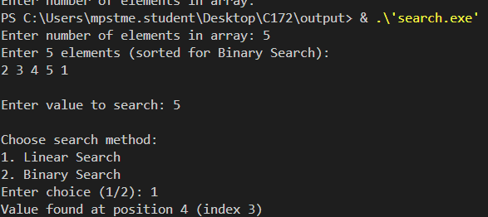

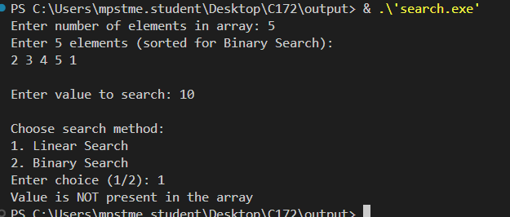

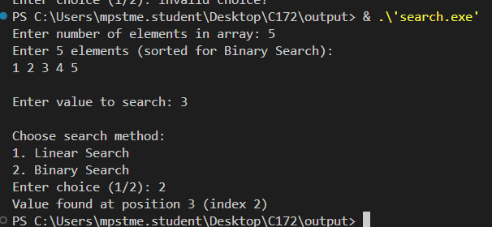

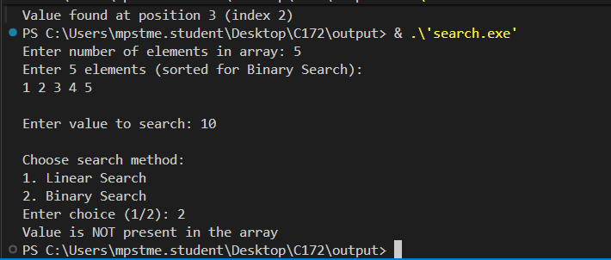
Observation & Learning:
Write your Observations & Learning after performing task
Curiosity questions:
- What is the time complexity of linear search and binary search?
• Linear Search
- Best Case: O(1)
- Worst Case: O(n)
- Average Case: O(n).
• Binary Search (array must be sorted)
- Best Case: O(1)
- Worst Case: O(log₂n).
- Average Case: O(log₂n).

- How many comparisons are performed in linear search and binary search for searching element 70 in the given array (10,20,30,40,50,60,70,80,90,100)?

For searching element 70:
  - Linear Search → 7 comparisons
  - Binary Search → 4 comparisons

Conclusion:
We successfully implemented searching algorithms

